WEB DEVELOPMENT ----> FRAME WORK

FRAME WORK ----> SET OF CODES THAT ARE ALREADY PREDEFINED

WEB FRAME WORK ----> WEB DEVELOPMENT

INSTALLING

**MTV -- > MODEL VIEW TEMPLATE**

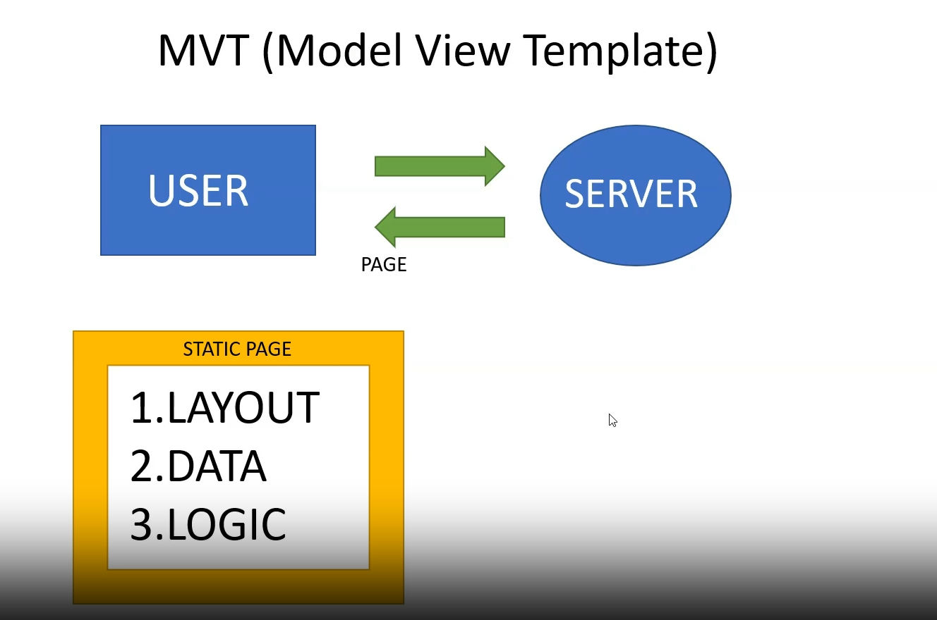

Website Using the template of website

1. Start Bootstrap
2. colorlib